Spring All Types of Confiurations

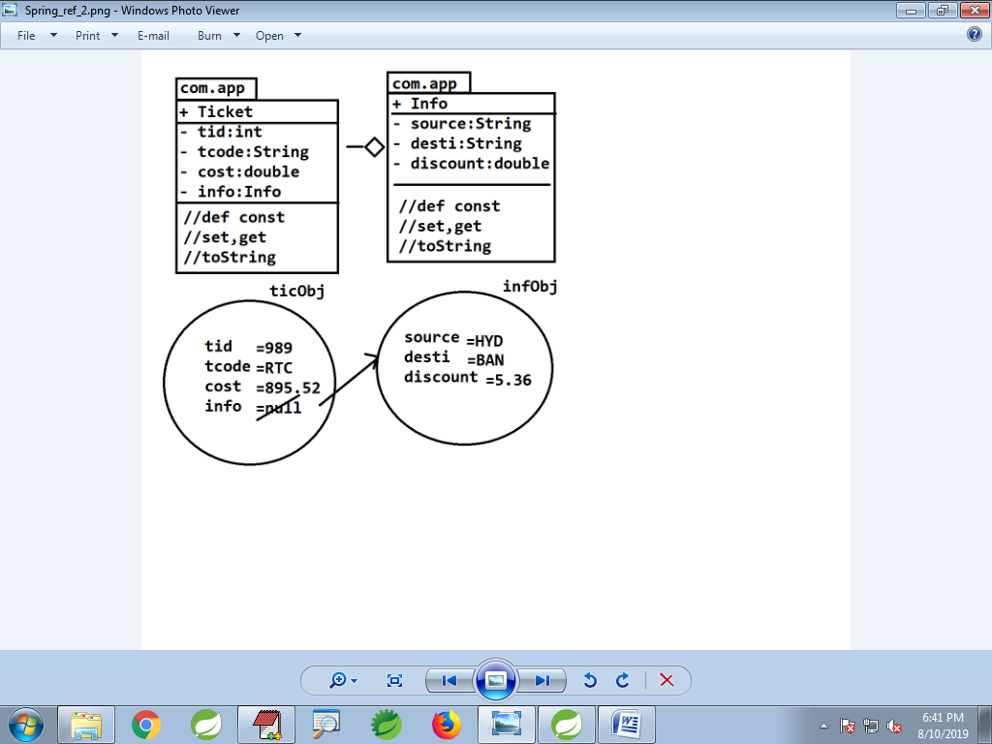

**--Code in Different Formats-------**

**1. Spring Beans**

**package com.app;**

**public class Info {**

**private String source;**

**private String desti;**

**private double discount;**

**//def const, set,get..toString**

**}**

**package com.app;**

**public class Ticket {**

**private int tid;**

**private String tcode;**

**private double cost;**

**private Info info;//HAS-A**

**//def const, set,get..toString**

**}**

**---------------Configurations------------**

**1. XML Configuration**

**a. Format#1 2 beans style**

**<bean**

**class="com.app.Info"**

**name="infObj"**

**p:discount="3.56">**

**<property name="source">**

**<value>HYD</value>**

**</property>**

**<property name="desti" value="BAN"/>**

**</bean>**

**<bean class="com.app.Ticket" name="ticObj"**

**p:tid="989">**

**<property name="tcode">**

**<value>RTC</value>**

**</property>**

**<property name="cost" value="526.6"/>**

**<property name="info" ref="infObj"/>**

**</bean>**

**#2 Inner Bean**

**<bean class="com.app.Ticket" name="ticObj" p:tid="989">**

**<property name="tcode">**

**<value>RTC</value>**

**</property>**

**<property name="cost" value="526.6" />**

**<property name="info">**

**<bean class="com.app.Info" name="infObj" p:discount="3.56">**

**<property name="source">**

**<value>HYD</value>**

**</property>**

**<property name="desti" value="BAN" />**

**</bean>**

**</property>**

**</bean>**

**Format#3 p-schema**

**<bean class="com.app.Info"**

**name="infObj"**

**p:discount="3.56"**

**p:source="HYD"**

**p:desti="BAN" />**

**<bean class="com.app.Ticket"**

**name="ticObj"**

**p:tid="989"**

**p:tcode="RTC"**

**p:cost="526.6"**

**p:info-ref="infObj"/>**

**----------------------------------------**

**2. Spring JAVA Config File**

**package com.app;**

**import org.springframework.context.annotation.Bean;**

**import org.springframework.context.annotation.Configuration;**

**@Configuration**

**public class AppConfig {**

**@Bean**

**public Info inf() {**

**Info i=new Info();**

**i.setSource("HYD");**

**i.setDesti("BAN");**

**i.setDiscount(3.69);**

**return i;**

**}**

**@Bean**

**public Ticket ticObj() {**

**Ticket t=new Ticket();**

**t.setTid(989);**

**t.setTcode("RTC");**

**t.setCost(36.6);**

**t.setInfo(inf());**

**return t;**

**}**

**}**

**Format#2 Generate Param const in two**

**Spring Beans (alt+shift+S,O >SelectAll>OK)**

**@Configuration**

**public class AppConfig {**

**@Bean**

**public Info inf() {**

**Info i=new Info("HYD","BAN",3.69);**

**return i;**

**}**

**@Bean**

**public Ticket ticObj() {**

**Ticket t=new Ticket(989,"RTC",36.6,inf());**

**return t;**

**}**

**}**

**-------------------------------------------**

**#3. Annotation Configuration \*\*\*\***

**package com.app;**

**//ctrl+shift+o**

**@Component("infObj")**

**public class Info {**

**@Value("HYD")**

**private String source;**

**@Value("BAN")**

**private String desti;**

**@Value("36.36")**

**private double discount;**

**//toString...**

**}**

**package com.app;**

**//ctrl+shift+O**

**@Component("ticObj")**

**public class Ticket {**

**@Value("88")**

**private int tid;**

**@Value("RTC")**

**private String tcode;**

**@Value("96.36")**

**private double cost;**

**//@Autowired**

**@Value("#{infObj}")**

**private Info info;//HAS-A**

**//toString..**

**}**

**FB:**

[**https://facebook.com/groups/thejavatemple**](https://facebook.com/groups/thejavatemple)

**Email:**

**javabyraghu@gmail.com**